Project Documentation
Streamlining IT Procurement: Automating Standard Laptop Orders with ServiceNow Flow Designer

Team ID: SWTID-2026-5598
Team Leader: PRIYANGA B -202400442@sigc.edu
Team Members:
USHALINI R - 202400788@sigc.edu
NIVETHA K - 202400333@sigc.edu
MONIKA R - 202400129@sigc.edu

1.Project Overview
This project automates the Standard Laptop procurement process in ServiceNow using Flow Designer. Once a laptop request is approved, the flow automatically creates a catalog task and assigns it to the Hardware team for configuration. This reduces manual work, minimizes delays, improves task management, and provides a faster and more efficient procurement process.

2. Project Objectives
- Automate the creation of catalog tasks for standard laptop requests.
- Automatically assign configuration tasks to the Hardware team.
- Ensure that tasks are generated only after the required approval.
- Reduce manual intervention in the procurement process.
- Minimize delays in laptop configuration.
- Improve resource utilization within the IT department.
- Provide a more efficient and consistent experience for users requesting laptops.
Task Initiation
Milestone 1: Flow
Create a Flow to Create Catalog task to update the short description after Approval the service Request and it will be Assignment group to Hardware.
The Standard Laptop Task Flow is created in ServiceNow Flow Designer to automate catalog task creation after a service request is approved.
Flow Configuration:
- Flow Name: Standard Laptop Task
- Application: Global
- Run As: System User
- Trigger: Service Catalog
Process:
1.Open Flow Designer in ServiceNow.
2.Create a new Flow.
3.Enter the flow name as Standard Laptop Task.
4.Select Global as the application.
5.Select System User under Run As.
6.Add a Service Catalog trigger.
7. Save the flow. 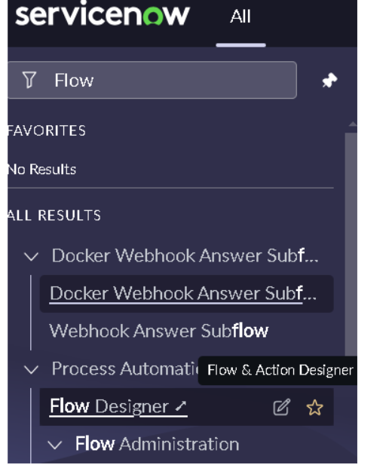
Flow Action Configuration
- Under Actions, click Add an Action.
- Search for and select Create Catalog Task.
- In Request Item, select Requested Item Record.
- The Table is automatically populated as Catalog Task.
- Enter the Short Description as: Laptop need to Configured
- Click Add Field Value and configure:
  - Description: Laptop need to Configured
  - Assignment Group: Hardware
  - Approval: Approved
- Leave the remaining fields as default.
- Click Done.
- Click Save to save the flow.
10.Click Activate, and click Activate again to confirm.
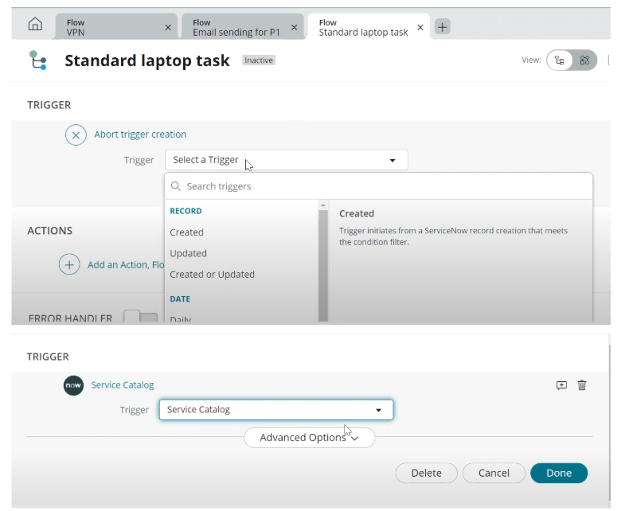
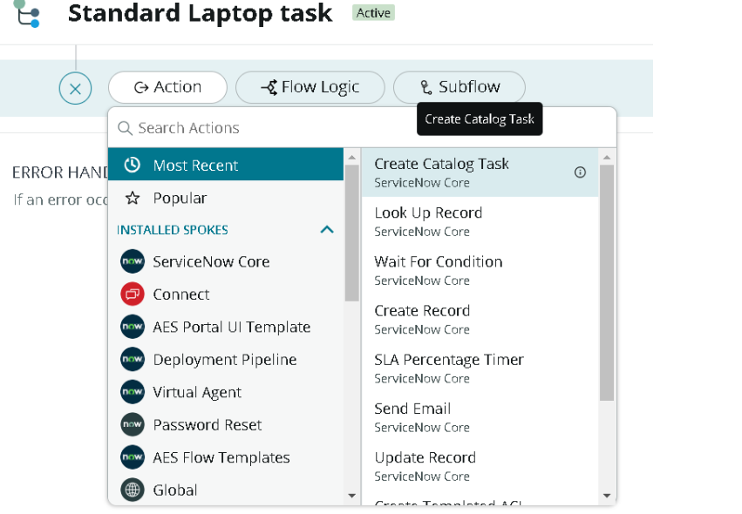
Milestone 2: Flow Assignment
Flow Assignment to Standard laptop service
Catalog.
1.Open ServiceNow.
2.Click All and search for Maintain Items.
3.Select Maintain Items.
4.In the Name field, search for and select Standard Laptop.
5.Open the Standard Laptop record.
6.Navigate to the Process Engine section.
7.Remove the existing automations, if required.
8.Select Flow.
9.Add the flow Standard Laptop Task.
10.Click the menu/save option to save the record.
Milestone 3: Service Catalog
Place Standard Laptop Order and Obtain Approval
- Open ServiceNow.
- Click All and search for Service Catalog.
- Open Service Catalog and select Hardware.
- Locate and select Standard Laptop.
- Click Order Now to place the request.
- Open the generated Request Number.
- Scroll down to the Approvers section.
- Right-click the approval record and select Approve.
- Open the Requested Item section.
10.Select the relevant Requested Item record.
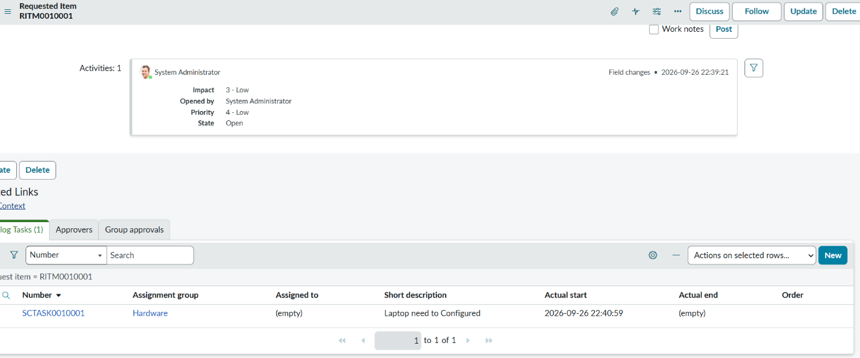
- Scroll down to the Catalog Tasks section.
- Open the created catalog task.
- Verify that the Short Description is updated to “Laptop need to Configured”.
14.Verify that the Assignment Group is set to Hardware.

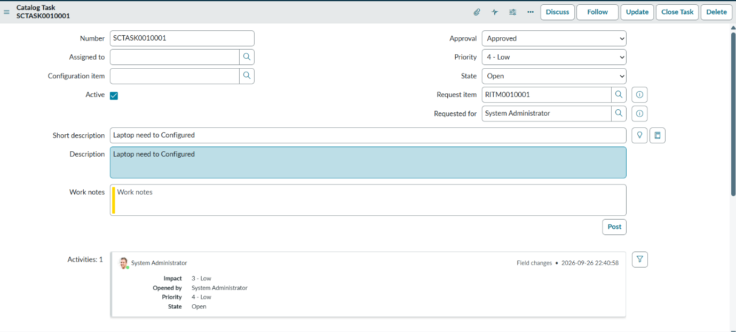
6. Tools and Technologies Used
Technology | Purpose
ServiceNow | IT service management and service catalog platform
Flow Designer | Workflow automation
Service Catalog | User interface for requesting a standard laptop
Catalog Task | Task generated for laptop configuration
Assignment Group | Routes the task to the Hardware team

7.System Requirements
. Platform: ServiceNow
- Application: ServiceNow IT Service Management (ITSM)
- Module: Service Catalog
- Automation Tool: Flow Designer
- Required Features: Service Catalog, Flow Designer, Catalog Tasks, Approval Management
- User Access: Admin or appropriate ITSM/Flow Designer permissions
- Configuration: Standard Laptop catalog item and Hardware assignment group
- Environment: ServiceNow instance with Flow Designer enabled
- Browser: Modern web browser such as Chrome, Edge, or Firefox
- Internet: Stable internet connection for accessing the ServiceNow instance
8.System Overview
The system uses ServiceNow Service Catalog and Flow Designer to automate the Standard Laptop procurement process. A user submits a laptop request through the Service Catalog, and after approval, Flow Designer automatically creates a Catalog Task and assigns it to the Hardware team for configuration. This reduces manual effort, improves task tracking, and speeds up laptop provisioning.
Demo Link: https://drive.google.com/file/d/1xTtEtmh0ER90QHW8YO6RN98PgFIwlsXb/view?usp=drivesdk
GitHub Link: https://github.com/Priyanga63698/StreamliningITProcurement.git

